

American International University-Bangladesh SET A

Faculty of Arts and Social Sciences

Department of English

B. Sc. Programs

**ENG 2103: Business Communication** (All)

**Final Examination**

**Total Marks: 40**  **Time: 2 Hours**

**Introduction**

School dropout has been defined as leaving education without obtaining a minimalcredential, most often a higher secondary education diploma. Estimates of dropout rates seem to be higher in South and West Asia (43%) and sub-Saharian Africa (36%), while other geopolitical areas such as East Asia, and Europe show similar lower dropout rates (between 4 and 12%) [1]. In Spain, where the present study is conducted, dropout rates are estimated as high as 22% with a greater incidence among males (26.6%) [2]. This study intends to probe the causes and consequences of school dropouts in Spain.

**Method**

The study included 264 participants selected from a population of young offenders, comprising 218 males and 46 females aged 14–18 years. A questionnaire titled *School Dropout Inventory* was developed using a scientific method, incorporating both close-ended and open-ended questions. The instrument's reliability and validity were established. Data analysis was conducted using the Statistical Package for the Social Sciences (SPSS).

Prior to participation, all willing respondents provided written consent. Participants received a briefing on how to complete the questionnaire and were informed about confidentiality, as well as their right to withdraw at any time. They were encouraged to ask questions and complete all sections of the questionnaire, which took approximately 10–15 minutes to fill out. Additionally, a focused group discussion was conducted for participants with limited reading proficiency to ensure accurate data collection.

**Results and Discussion**

[[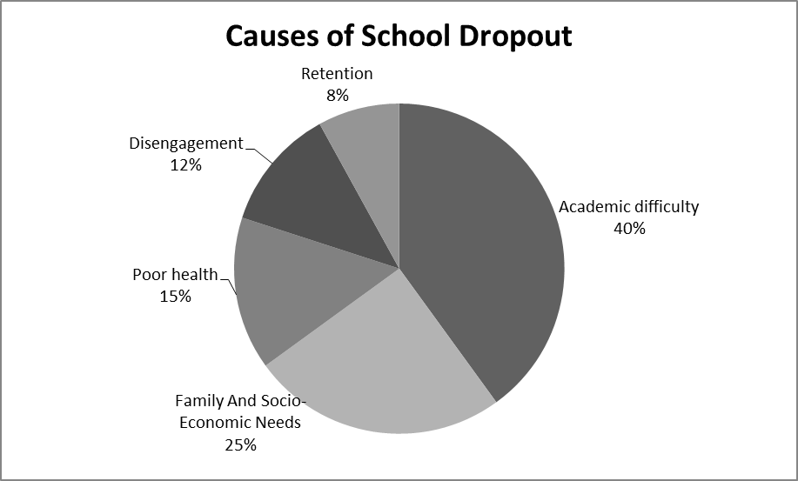

*Figure 1: Causes of School Dropout*

A number of consequences have been identified from this study where figure 2 shows that school dropout mostly leads to the unemployment crisis in the country as well as juvenile crimes. When school dropouts struggle to get a job and fail at the end, they suffer from mental breakdown. Some of them seek refuge by taking drugs. Though many students drop out of school because of their family but ironically after being dropouts they become a burden for their own family. Most school dropouts are considered inefficient to get a high-wage job. Their families, consequently, need to cope with lower income.

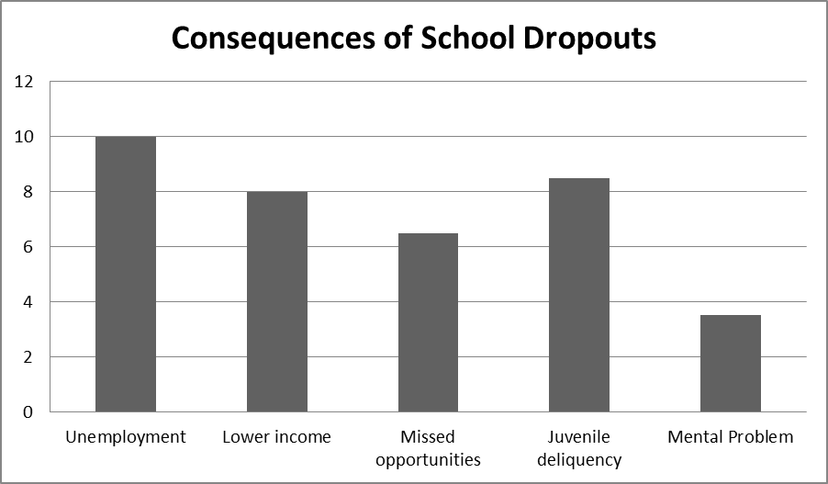

*Figure 2: Consequences of School Dropouts*

Diverse responses are received from the survey to the following issues: Causes of School dropouts, individual problems faced by this issue, the ratio of school dropouts between males and females, Consequences of School dropouts and how to reduce this rate of dropping out.

From Figure 1 it can be stated that students’ incapability to cope with academic pressure is the main reason for leaving school. Around 40% of participants said that their difficulty level in Math, English and Science has made them compelled to leave the school in 8th grade. Many children from poor families are obliged to support their families. As a result, they cannot concentrate on their studies and about 25% of participants left their school for this reason. The health of a child greatly affects his learning ability and performance at school. Illnesses that occur during childhood and continue lifelong generally curb a child’s ability to complete school. Retention has a negative impact on the self-esteem of children. They feel bad being older than their classmates and tend to drop out of school. Many kids find school boring. According to this study, almost 12% of students become disinterested in high school while they are in the 9th and 10th grades. They prefer to go late to school, skip classes and take long lunch breaks. The lack of interest often leads to dropping out of school. Some students find it difficult to connect with the teacher. A majority of students did not feel their teachers motivated them enough to work hard.

**Conclusion**: As school dropouts can be a national crisis, experts think that a number of practical initiatives can abate this threat. Teachers need to engage the parents in the students’ academic performance. Weak students need to be under special care by the school authority. Involvement in extracurricular activities can motivate students to be with their schools. This study suggests reducing the cost of education, modifying school schedules, providing mental health support at school and, most importantly, implementing career-oriented education system can minimize this national crisis.

1. **Read the short paper above and answer the following questions. 4X1=4**
2. Write a suitable title for the report./ What is the main purpose or objective of the paper?
3. What methods were used to collect the data?
4. What are the key findings or results of the research?
5. What are the implications or potential applications of the research?
6. **Write an abstract for the above report in 100-120 words. 7**
7. **Write short notes on any three of the following topics. 3X2=6**

Key words, Plagiarism, Qualitative vs Quantitative research, Primary vs Secondary data, IEEE

1. **Rewrite a methods section based on the following sample research context and data. 8**

Title:  
*Social Media Use and Academic Performance Among University Students*

Objective:  
To explore the relationship between daily social media usage and students' academic performance over a semester.

Study Setup:

* Location: A mid-sized public university
* Duration: 12 weeks (one academic semester)
* Participants: 120 undergraduate students across 4 faculties

Data Collection:

* Method: Online self-reported survey
* Tool: Google Forms
* Frequency: Weekly survey submissions
* Data Collected: Average daily time on social media, types of platforms used, GPA scores, and study habits

Data Summary:

* Most students reported 3–5 hours of daily social media use
* Instagram and TikTok were the most used platforms

Data Analysis:

* Quantitative data processed in SPSS
* Descriptive statistics and correlation analysis used
* Patterns explored across gender and field of study

1. **Analyze the following data and write a brief Discussion section as part of a research report. Write approx. 150 words. 10**

In your discussion, be sure to:

* Interpret the key findings from the data
* Highlight any surprising or significant patterns
* Suggest possible implications or applications of the findings (If any)

The pie chart below gives statistics of natural causes of earthquakes and the table gives the information of the percentage of the earthquake occurred by the regions.

1. **Using the information provided below, create a properly formatted References list following the IEEE citation style. 5**

1.

Author(s): Maria Gonzalez

Title: Digital Learning in Higher Education

Publisher: Academic Press

Year: 2021

Pages: 69-98

City: New York

2.

Author(s): T. Nguyen and L. Patel

Article Title: “Social media use and student engagement in online learning”

Journal: Journal of Educational Technology

Volume: 18

Issue: 3

Pages: 45–52

Month/Year: July 2022

3.

Author(s): World Health Organization

Title: Mental Health and COVID-19: Early Evidence of the Pandemic’s Impact

Website: www.who.int/publications

Accessed: February 10, 2025

Year Published: 2023

4.

Author(s): H. Sato

Paper Title: “AI-assisted language learning tools: A case study”

Conference: Proceedings of the 2023 International Conference on E-Learning

Location: Tokyo, Japan

Pages: 77–83

Year: 2023

5.

Author(s): J. Smith, R. Li, and A. Kumar

Title: Introduction to Data Analytics

Edition: 2nd ed.

Publisher: TechBooks Publishing

Year: 2020

City: Boston